**SOP FOR**

1. **PURPOSE: Safe maintenance of Hydraulic equipment.**
2. **SCOPE:** **Blast Furnace Accessories .**
3. **RESPONSIBILITY: Engineer in charge & workmen on the job .**
4. **PROCEDURE: Maintenance Of Hydraulic Equipment.**

PPE –s to be used:

• Safety shoes, helmet, cotton cloth, ear plugs, goggles and hand gloves.

Aspect – Impact

|  |  |
| --- | --- |
| Oil Spillage | Land contamination & Resource Depletion |
| Oil traced waste generation  **Hazards Identified:** | Land contamination & Resource Depletion |
| **Mechanical hazards** | | |
| 1. Trapping between the moving parts | | |
| 2.  Impact of hammer, tools, components. | | |
| 3.   Fall of materials such as hammer, pipe wrench, spare parts, bolts, spanners, slinged items. | | |
| 4.    Entanglement between rotating components. | | |
|  | | |
| Human behavior aspect : | | |
| 1. Alcoholism, non usage of PPE's, workmen nature and casual approach | | |
| Physical hazards | | |
| 2.      Pressure of hydraulic oil. | | |
| 3.      Temperature of oil. | | |
| 4.      Fall of oil in eyes, ears, mouth | | |
|  | | |
| Electrical hazards | | |
| 1.      Electrical shock | | |
|  | | |
| Chemical Hazard | | |
| 1. Fire. | | |

**Work No 1 : Hydraulic Pump /Motor replacement**

**Work No.2 : Nitrogen pressure checking & charging into the accumulators**.

**Work No. 3 : Bladder replacement .**

**Work No.4 : Hydraulic cylinder & hose replacement**

**Work No.5 : DC vv, flow control vv, check vv & Pressure Relief vv Replacement & leakage arresting.**

**Work No.6 : Hydraulic power pack suction filter replacement**

**Work No.7 : Hydraulic power pack Return line filter replacement**

**Work No 1**:: **Hydraulic Pump /Motor Replacement**

1)Take electrical s/d. of pump-motor to be replaced by Loto.

Mechanical isolation of powerpack pressure line and return line valve to be taken

& handover the loto box to workmen for group loto

2) Take Work Permit from Operation department for carrying out the job

4)**For changing** **Pump assembly, follow below procedure**:

1. Close the suction valve .
2. Loosen the suction flange & discharge end hose ,
3. Now remove the mounting bolts of hydraulic pump & dismantle the same from position.
4. Inspect the coupling condition & change if needed .
5. Ensure that the new coupling is having a step, so that both couplings (motor- pump) do not get pressed against each other. Also ensure that the coupling Is locked on the shaft by means of grub screw.
6. Assemble the pump and kindly ensure for a minimum float of 5mm in Nylon coupling .
7. Fix suction flange , replace “O” rings if needed .
8. Fill some amount of clean hydraulic coil into the pump via the discharge end to ensure that pump does not run dry during initial rotation .
9. Connect the discharge end hose .
10. Open the suction line valve.
11. Remove electrical and mechanical shutdown and take trail.

4)**For changing the motor assembly**,

a) Ensure that minimum 2 ton certified chain block is used for lifting the motor

Take electrical shutdown of particular motor.

b) Once cables are disconnected by electrical , start loosening the motor foundation bolts.

c) Now slide the motor backwards to disengage from the coupling , then slowly lift the motor from its foundation frame & lower it on the ground by means of proper handling arrangement.

d) Lift the spare motor and mount it on the frame,

e) Tighten all the foundation bolts after checking the alignment.

f) Ensure that there is a ,minimum 5 mm float in nylon coupling.

6) Clear s/d. & take trial of pump-motor & give clearance and Also to take vibration reading of electrical motor

7) Clear Work permit .

**Work No.2 : Nitrogen pressure checking & charging into the accumulators**.

1. Take clearance from Operation dept. by taking work permit .
2. For checking Nitrogen pressure
3. Close the isolation valve of the accumulator whose Nitrogen pressure needs to be checked as shown below .

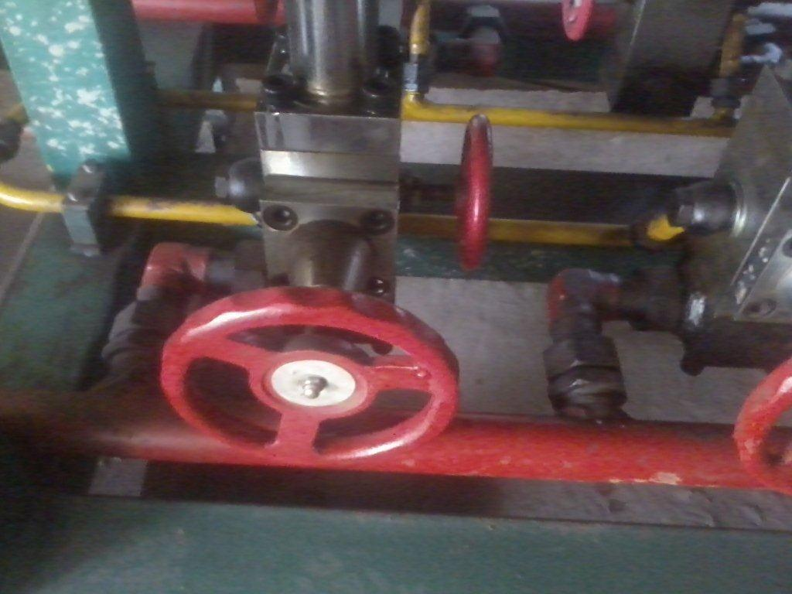

Close this valve

1. Open the drain line valve in order to drain the oil from the accumulator as shown below .



Open this valve.

1. Open the top cap of accumulator.

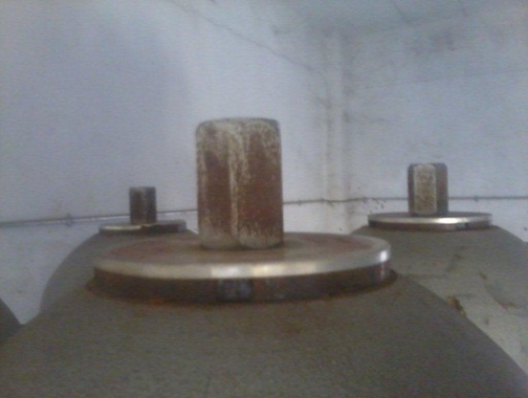

1. Connect the regulator on top of accumulator as shown below & tighten it

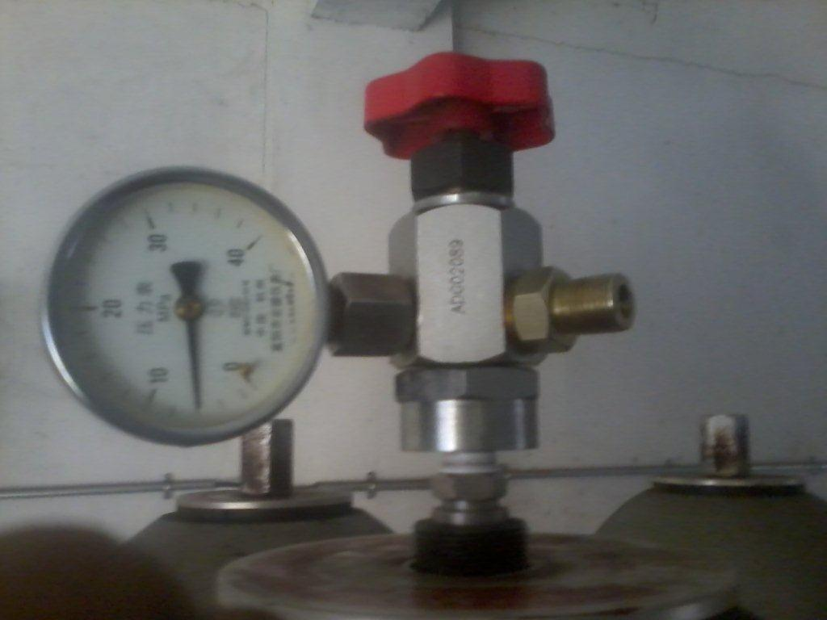

1. Ensure that release knob is kept tightened

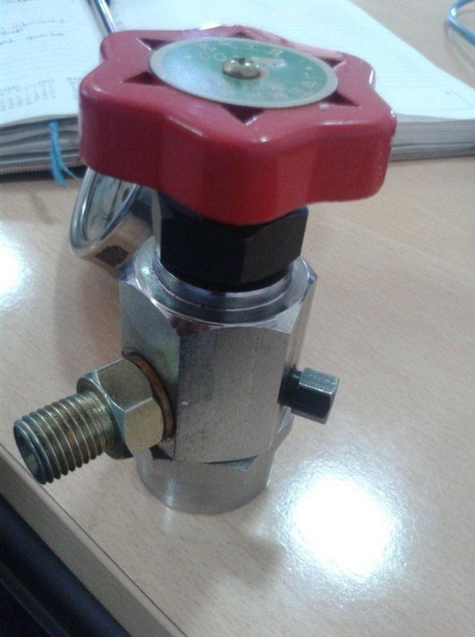

Release knob to keep tightened.

1. Now Tighten the red colour operating knob & check the Nitrogen pressure on the gauge.
2. Check the required pressured of Nitrogen as per the table given below .
3. Incase Nitrogen pressure is less then the required pressure then follow the procedure for Nitrogen charging .

Note: Nitrogen pressure needs to be 60% of operating pressure of the system .

|  |  |
| --- | --- |
| **Area :BLT** | |
| **No. of accumulators** | **4** |
| **Operating pressure** | 16Mpa |
| **Recharge pressure** | 8 Mpa |
|  |  |
| **Area : Stock House** | |
| **No. of accumulators** | **4** |
| **Operating pressure** | 8Mpa |
| **Recharge pressure** | 5Mpa |
|  |  |
| **Area : HBS** | |
| **No. of accumulators** | **6** |
| **Operating pressure** | 10Mpa |
| **Recharge pressure** | 6 Mpa |
| **Area: Tilter** | |
| **No. of accumulators** | **1** |
| **Operating pressure** | 20Mpa |
| **Recharge pressure** | 10 Mpa |

1. For Nitrogen charging into the accumulator
2. Follow steps (**a)** to (**e)** of nitrogen pressure checking.
3. Connect suitable hose to regulator at one end & other end should be connected to the Nitrogen cylinder .

**Note**: **Only 99.999% pure nitrogen should be charged in to the accumulator. Charging of impure nitrogen/oxygen/compressed air can lead to explosion**. Nitrogen cylinder pressure should be 10% higher than the accumulator required pre charge pressure .

1. Tighten the red colour knob.
2. Open the nitrogen cylinder valve by turning the key .
3. Pressure can be seen on the gauge provided on regulator .This pressure should be checked against the required pressure of the accumulator as per the table shown above.
4. When required Nitrogen pressure is indicated on the pressure gauge , close the cylinder valve .
5. Now the accumulator is charged .Disconnect the regulator from the accumulator.
6. Open the valves as shown below .
7. Give clearance to operation dept. & clear the work permit.



Open

Close

**Work No. 3 : Bladder replacement .**

a. Take work permit to carry out the job.

c. Isolate the accumulator by closing the inlet valve to the accumulator & take mechanical isolation.

d. Drain the oil from the accumulator by opening the pressure release valve below the accumulator cylinder.

e. Drain nitrogen from the bladder to the atmosphere by connecting the regulator & opening the release knob.

f. Disconnect the connections of the accumulator, and slowly lower the cylinder using a manila rope.

g. Remove the lock nut on top of the cylinder and the take out the bladder from it.

h. Put the new bladder in to the cylinder. While doing this, it has to be ensured that there is no dust on the bladder.

i. Put the cylinder back on to the stand using a manila rope and make all the connections.

j. Charge the Nitrogen into the accumulator as per Nitrogen charging procure mentioned above.

**Do’s**

* Ensure that the motor eye bolt is in good condition before lifting it.
* Nitrogen used for charging is 99.999% pure.
* Housekeeping is carried out after job completion.
* Do housekeeping activity as per WI/MAINT/91

**Don’ts**

* Carry out Nitrogen filling exercise with non calibrated pressure gauge.

**Work No. 3 : Hydraulic Cylinder & Hoses replacement.**

1. **Take work permit to carry out the job**

**Hydraulic shut-off vv to be closed , isolate the system by** mechanical isolation of powerpack pressure line valve and return line valve  **by Loto lock & followed by group loto.**

1. **Remove the hoses & collect the oil in empty bucket.**
2. **Remove the cylinder mounting bolts & remove the pin**
3. **Replace the cylinder, place pin & bolts to be tighten**
4. **Hoses replacement to be done & open the isolation lock & hydraulic vv to be opened.**
5. **Trail to be taken by operating manually from power pack by inching.**
6. **Take trail from control room & clear work permit.**

**Work No.5 : DC vv, flow control vv, check vv & Pressure Relief vv Replacement & leakage arresting.**

1. **Take work permit to work this job & co-ordinate with Area incharge**

**Hydraulic shut-off vv to be closed & isolate the system by Loto lock,** mechanical isolation of powerpack pressure line and return line valve  **by Loto lock & followed by group loto.**

1. **Release hydraulic oil pressure by operating valve handle.**
2. **Loose allen bolts and collect oil in tray.**
3. **Replace New or Serviced DC, Flow control, Check or pressure relief vv and tighten the allen bolts**
4. **Open the isolation lock & hydraulic vv to be opened.**
5. **Clear the work permit & mechanical isolation.**
6. **Take trail & give clearance to operation department.**

**Work No.6: Hydraulic power pack suction filter replacement**.

Take work permit & electrical Shut down of Hydraulic Pumps mechanical isolation of powerpack pressure line and return line valve  **by Loto lock & followed by group loto.**

1. Take Empty Clean Barrels according to tank capacity.

Note: Ensure Empty Barrels should be clean

1. Connect suction hose of ELC Machine to power pack drain valve & delivery hose of ELC machine to Empty Barrel.
2. Start ELC m/c in Forward Mode & Collect hydraulic oil in Empty barrels and stop ELC m/c after power pack gets empty.
3. Remove power pack baffle plate & clean inside the power pack.
4. By loosening cap of suction filter housing replace the suction Filter.
5. After work completion, suction filter housing cap to be fitted back.
6. Now start ELC m/c in Reverse Mode & Fill the hydraulic oil from Barrels to Power Pack.
7. Take trail by clearing shut down of Hydraulic pumps.
8. Give clearance to operation department by clearing work permit.

**Work No.7: Hydraulic power pack Return line filter replacement**.

Take work permit from operation department.

mechanical isolation of powerpack pressure line and return line valve  **by Loto lock & followed by group loto.**

1. Open by-pass valve of Return line & close hydraulic shut-off valve of return line .
2. Remove Return filter housing cap by loosening.
3. Replace the Return line filter & fit back its cap.
4. Open hydraulic return line shut-off vv & close by-pass return line shut-off valve.
5. Clear work permit from operation department.

**REFERENCES: Operation & Maintenance manual.**

**Amendement Record**

|  |  |  |  |
| --- | --- | --- | --- |
| **Date** | **Manual Section Ref. & Para** | **Brief details of Revision** | **New Rev.** |
|  |  |  |  |
|  |  |  |  |
|  |  |  |  |

|  |  |  |
| --- | --- | --- |
| **Prepared By:**  Area Engineer | **Reviewed & Issued By:**  Management Representative | **Approved By:**  Mechanical Head |
| **Signature:** | **Signature:** | **Signature:** |
| **Review Date: 08.01.2023** | **Review Date: 08.01.2023** | **Review Date: 08.01.2023** |